Automobile Engine Check and management in crisis: Fuzzy System

# Description

We all have seen engine light turning on. Maybe when we tried to start old car sitting in garage for a long time, or sitting in a friend’s car who is careless about maintenance and service, and wondered how long will it go before breaking down. What if we are on a long trip and suddenly engine light comes on in the middle of nowhere? Do you stop and call for tow truck or do you drive till next service center risking total breakdown? This is the issue for which we will try to develop an expert based system for

The developed solution can manage engine crisis and its goal is to get maximum distance out that engine without destroying it in the process. The system will be cable of taking multiple aspects of an automobile such engine temperature, engine RPM, fan speed, available fuel before making decisions.

Following is an overview of how system will integrate into the automobile system

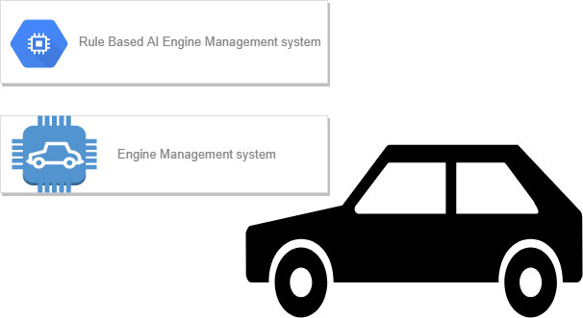

The Rule based AI engine management system sits on top of engine management system installed by car manufacturer. This AI system kick in as soon as engine light comes on. The idea is to effectively manage resources to maximize the distance the car can do.

In the project implemented around 15 fuzzy rules have created which covers scope of this project. creating more rules just for the sake of it would have made the system cluttered with unnecessary rules

Following are the things that the system takes into consideration

* Engine Temperature
* Oil Temperature
* Oil Level
* Fuel Level

To maximize the total distance the fuzzy system changes the following parameters based on the above inputs

* Car Speed
* Engine Fan Speed (ranges from 1 to 10)

The System is also capable of handling low car speeds and it controls Hazard light whenever car speed is low

# Testing

Based on the previous suggestions provided by the evaluator, the documentation part been majorly updated. This time around the code is very readable with comments on everything that has been done in the project. To help evaluator better understand the code and how it is working printout statements with relevant data has been added in all the places.

## Running the application

Assuming you have eclipse with fuzzy jars imported which are mandatory for Fuzzy project to run. Please make sure run configuration of the project is as shown below before you run the project. otherwise you will run into issues

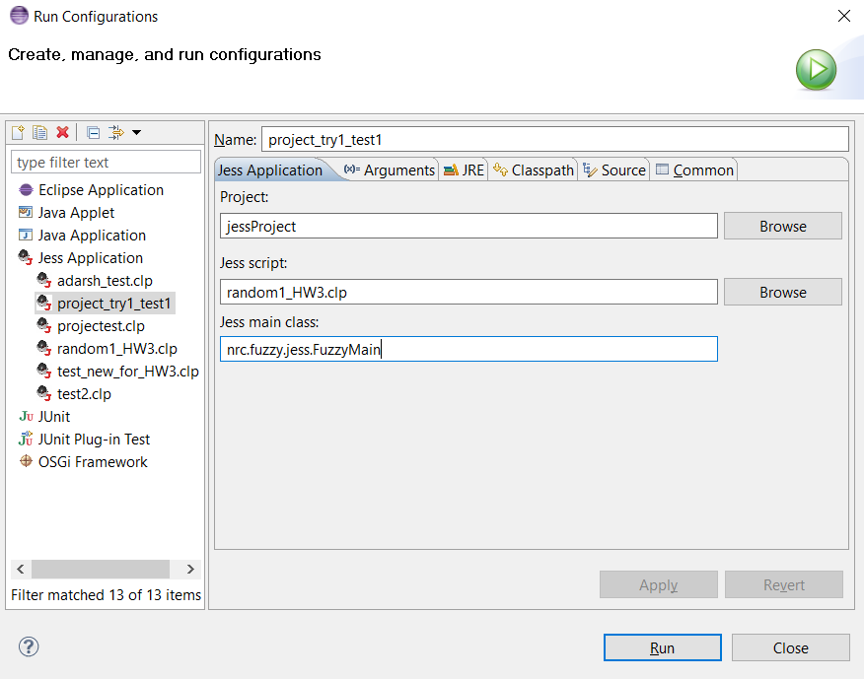

## Output

Once the project successfully runs, You will get an output like shown below

The result is calculated based on the value given in the assert statement entered after line. to better understand the working under the hood printout statements have been placed for each rules and data initialization methods.

; asserting the user data. please change here to change the system input

Jess, the Rule Engine for the Java Platform

Copyright (C) 2008 Sandia Corporation

Jess Version 7.1p2 11/5/2008

This copy of Jess will expire in 1797 day(s).

==============Data initialization and assertion================

Initializing the engine temperature data

Initializing the oil temperature data

Initializing the fan speed data

Initializing the car speed data

Initializing the engine oil level data

Initializing the fuel level data

Asserting the data given by the user

=======================Rule trigger===========================

Following rules are trigged with the given input

Triggering rule 13 for high fuel level: 92.64322916666669

Triggering rule 10 for high oil level: 98.52864583333334

Triggering rule 5 for low oil temperature: 35.3125

Triggering rule 4 for high engine temperature: 194.40885416666663

======================Analysis and result====================

!!Welcome!!

Following things are enforced or recommended for your car: Volkswagen Beetle of year 2016

Radiator fan speed is set to 3.7393433927111133

Car speed is limited 32.964380308147575

Hazard light is: ON

Please feel free to play around with the system by entering the custom values that you would like to try.

-Boyka